

Supply Chain Partnerships as a model of collaboration across the voluntary ,community and social enterprise (VCSE), public and private sectors

**Report**

**September 2014**



Table of Contents

Introduction 1

Background 1

Supply Chain Partnerships as a model of collaboration across the VCSE, public and private sectors 1

Defining the Supply Chain 3

Supply Chains within the Northern Health and Social Care Trust (NHSCT) 4

Supply Chains for Housing Associations, untapped potential? 7

Setting up and managing a Supply Chain 9

Reflections from research and policy on supply chains in England 11

Key Messages 13

# 

# collaboration programmeIntroduction

## Background

CollaborationNI (CNI) was formally launched on 30 March 2011, as a partnership programme between NICVA, CO3 and Stellar Leadership, commissioned by Building Change Trust. CNI provides practical support and resources across the whole spectrum of collaborative working to voluntary and community sector organisations.

As part of Phase One of CNI, 553 events were held covering training, expert facilitation, legal support sessions, coaching and policy seminars for over 4,000 individuals from 754 organisations.

Phase Two aims to produce a smaller number of deeper collaborations which will influence policy and decision makers. It will see an extension of the debate through a range of policy symposiums which will continue to challenge our thinking, examine current approaches and focus on particular models of collaboration, under a number of thematic areas, including health, social housing, young people, arts, criminal justice and older people.

The aim of the policy symposiums is to challenge, inform and develop political and government thinking about the support requirements of the Voluntary, Community & Social Enterprise (VCSE) Sector to encourage and cultivate a culture of effective collaboration.

The broad range of discussion will also provide an opportunity for VCSE Sector leaders and government officials to learn from good, and not so good, practices in Northern Ireland and elsewhere in building effective collaborations, resulting in improved services and better client outcomes.

## Supply Chain Partnerships as a model of collaboration across the VCSE, public and private sectors

The CNI and Social Enterprise NI policy symposium was held in the Long Gallery, Stormont Buildings, Belfast, on Tuesday 23rd September 2014, to consider ‘Supply Chain Partnerships as a model of collaboration across the VCSE, public and private sectors’. Sixty-five attendees from across the VCSE Sector, government, and the private sector participated in the symposium and heard from examples of good practice, and not so good practice, in Northern Ireland, and elsewhere, in building effective collaborations which result in improved services and better client outcomes.

The symposium provided an opportunity to:

* Clarify what is known and what is not known about supply chain partnerships as a model of collaboration;
* Outline the main theories and perspectives on supply chain partnerships;
* Identify the dominant models of partnerships;
* Assess the benefits and drawbacks of these models;
* Examine critical success factors and best practice for partnerships;
* Identify gaps in knowledge and how they can be filled;
* Be clear about what is widely accepted understanding, what is our analysis and what is new thinking; and
* Draw out the key implications for the VCSE Sector.

Collaborating in more horizontal structures can allow organisations to play to their strengths and work flexibly, something that is more difficult in a traditional, vertically integrated organisation model. The event provided an overview on cross sectoral supply chains, examples of what worked and lessons learned.

The symposium was addressed by four leading professionals on both the theory and practical applications of supply chains. They were:

* **Hugh Nelson**, Northern Health and Social Care Trust – Supply Chains within the Northern Health and Social Care Trust (NHSCT);
* **Cameron Watt**, Northern Ireland Federation of Housing Associations – Supply Chains for Housing Associations, untapped potential?;
* **Liam McNeill**, Bryson Charitable Group – Setting up and managing a Supply Chain; and
* **Dr. James Rees**, VCSE Sector Research Centre (TSRC) – Lessons learnt from research on supply chains in England and Wales.

Following the four presentations, participants were given the opportunity to discuss emerging themes in more detail and to look at Supply Chains as a model of collaboration for VCSE Sector Organisations.

# Defining the Supply Chain

Whilst there are numerous definitions of what a supply chain is, the two examples which are most relevant to VCSE Sector Organisations (VCSESOs) and the operation of supply chains in Northern Ireland, are:

*“A supply chain is the network of organizations that are involved, through upstream and downstream linkages, in the different processes and activities that produce value in the form of products and services delivered to the ultimate consumer.”*

- Christopher Martin L. (1992)

*“A series of integrated enterprises that must share information and coordinate physical execution to ensure a smooth, integrated flow of goods, services, information and cash through the pipeline.”*

- Coyle, Langley, Novak & Gibson (2013)

In practice supply chains deal with the provision and procurement of contracts and the relationship between contractors, suppliers, sub-contractors, customers and clients.

Due to changes in the way that government contracts are being awarded, primarily in Great Britain, there has been a very real need for VCSESOs to work more closely, and in partnership, with a wide range of public and private sector organisations. This has extended across the UK, since the election of the coalition government in 2010, which has seen a marked shift away from the direct provision of grant aid to the VCSE Sector, to a commissioning model which is almost entirely outcome based. The implications of competitive tendering for the VCSE Sector will be far reaching and long lasting.

As a direct result of this, there is now an increased requirement and in some cases a necessity for VCSEs to learn more about supply chains and changes in public procurement policy, which require a multiplicity of relationships, and for them to understand the importance of integrated networks and partnerships.

The change in approach by the UK government will obviously have an impact on VCSESOs in Northern Ireland and will present opportunities and threats for locally based organisations. We have witnessed a growing trend whereby Northern Irish VCSESOs are now being treated more like private and public sector organisations, having to compete for government contracts on the same footing as all other private sector organisations.

The growing trend by central government in London, as well as the devolved administrations in Edinburgh, Cardiff and Belfast, which favours competitive tendering, over the traditional pathway of the direct provision of grant aid to the VCSE Sector, raises a number of interesting challenges and opportunities. Within this context this report will examine VCSESOs involvement in supply chains as a model of public service delivery.

It will examine the opportunities for VCSESOs to apply for contracts at different stages of the supply chain- from lead contractor, to mainstream providers, to specialist programme providers, to specialist provision-which should allow for VCSESOs, of different shapes and sizes, to engage in the public procurement process at a level which is appropriate for them.

In Northern Ireland, a key priority of the current Programme for Government (PfG) is, “to deliver high quality and efficient public services”[1]. The PfG also gives a clear commitment to, “include social clauses in all public procurement contracts for supplies, services and construction.[2]”

The Northern Ireland Executive’s Economic Strategy has a number of key priorities, one of which is a rebalancing of the economy, from the current model which is overly dependent on the public sector, to one which has a greater role for the private sector. One of the key rebalancing measures is tom increase business growth by, “Invest[ing] in social enterprise growth to increase sustainability in the voluntary and community sector[3].”

The clear commitment shown by the Executive to the VCSE Sector, in both the PfG and the Economic Strategy, are evidence of the fact that even in an increasing competitive public procurement sphere there is still a central role for VCSESOs. Within the context of the commissioning framework, it is vitally important that the potential of supply chains as a form of partnership between the public, private and VCSE Sectors are fully investigated and maximised.

# Supply Chains within the Northern Health and Social Care Trust (NHSCT)

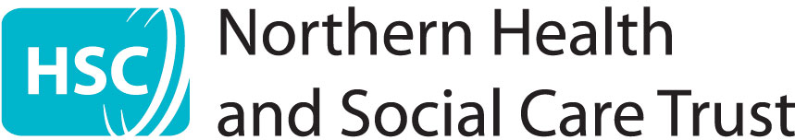

The Northern Ireland DHSSPS is the largest NI government department and has an annual budget of £4.7bn, representing almost half of the total budget. Of this budget DHSSPS procures the provision of external contracts, through a public procurement process of approximately £750m per year. The Northern Health and Social Care Trust (NHSCT) is one of five health trusts in Northern Ireland and provides services for approximately 460,000 people, the largest resident population in Northern Ireland, across ten council areas.

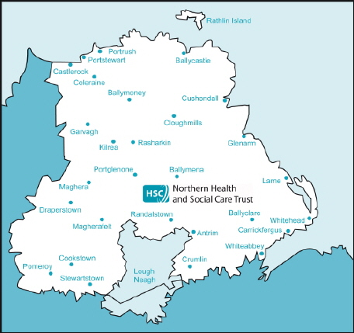Traditionally, the VCSE Sector in Northern Ireland has played a central role in the provision of services which help people live independently, and the Department of Health, Social Services and Public Safety’s (DHSSPS) Social Economy Strategy expresses a commitment to developing a healthy social economy, by raising awareness and building partnership working. DHSSPS’s review into health and social care provision in Northern Ireland, Transforming Your Care (TYC), places an emphasis on moving clients out of adult day centres and into vocational and educational services which are provided in real world settings- a development that provides numerous opportunities for VCSESOs and social enterprises.

The NHSCT, in line with thinking across the public service, is an increasingly centralised structure, which places an emphasis on regional operations and places a high premium on securing value for money. This again presents opportunities and threats for VCSESOs, which have traditionally placed focus on providing a ‘value added’ service which very often produces a very high quality service, with less emphasis being placed on cost. Whilst there is now a greater expectation that VCSESOs will engage in the procurement process with a private sector mentality, the NHSCT wishes to build on long established relationships with VCSESOs that look at more than just value for money but looks at the quality of the service and the wider societal benefits that are provided by the VCSE Sector.

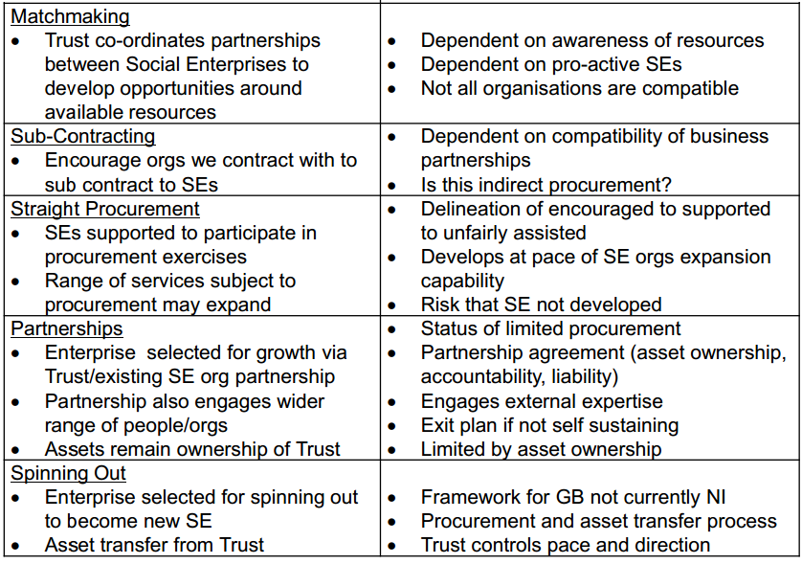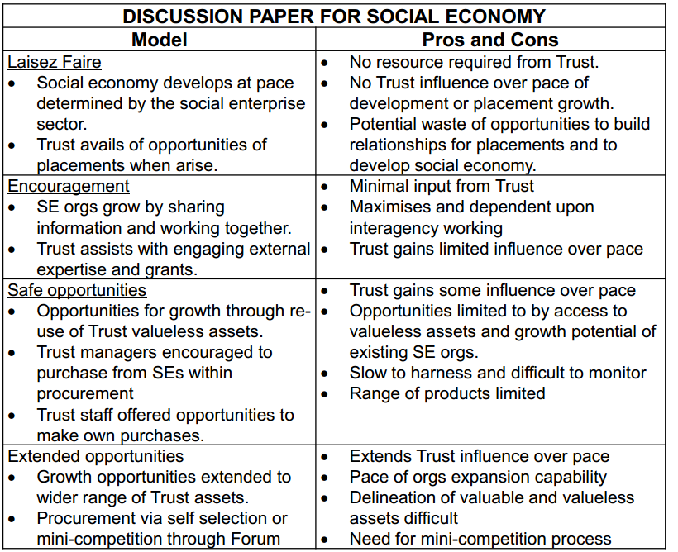Organisations which are willing to engage in different models of collaborations will be able to expand from their own area of expertise whilst at the same time learning from the experience of others, which will deliver benefits to the entire VCSE Sector. By building on long established relationships VCSEs would be able to maximise their ability to compete for contracts through public procurement exercises in a fair and transparent way.

The NHSCT have taken innovative steps in order to assist VCSSOs including:

* An initial pilot project which offers up to £100k to stimulate growth for social economies who work with the Trust;
* Waste cooking oil from hospitals is given to a social economy which recycles it into bio-oil which has obvious benefits for the social economy and also means that the Trust no longer have to pay for the oil to be removed.

The biggest challenge, arising out of the change in focus from the DHSSPS, facing VCSEsOs is the shift from merely the provision of day centres towards the notion of developing day opportunities for adults with learning difficulties. DHSSPS are now more focused on ensuring clients gain qualifications and then move on to other opportunities, rather than on simply providing care. Outcomes now have to be measurable and quantifiable and can no longer be defined as the provision of a protective, supportive environment.

DHSSPS want to see a more collaborative, partnership focused approach and want to work with a range of service providers who can build partnership for the benefit of clients. With further diversification in the market, through the introduction of a personal allowance system, which will allow families to make decisions on what services they wish to purchase, VCSESOs will have to be increasingly flexible and be prepared to offer tailored, bespoke services, based on the individual needs of clients. However, the present public procurement and contracting system often restricts innovation and creative approaches, which are often offered by VCSESOs, and this is something that will have to be addressed in order that VCSESOs are able to continue to compete for contracts.

# Supply Chains for Housing Associations, untapped potential?

Housing Associations are one of the major providers of housing care and support services in Northern Ireland. Housing Associations first came into being in 1976 and today there are 26 associations, including the Northern Ireland Co-ownership Housing Association, and they are responsible for:

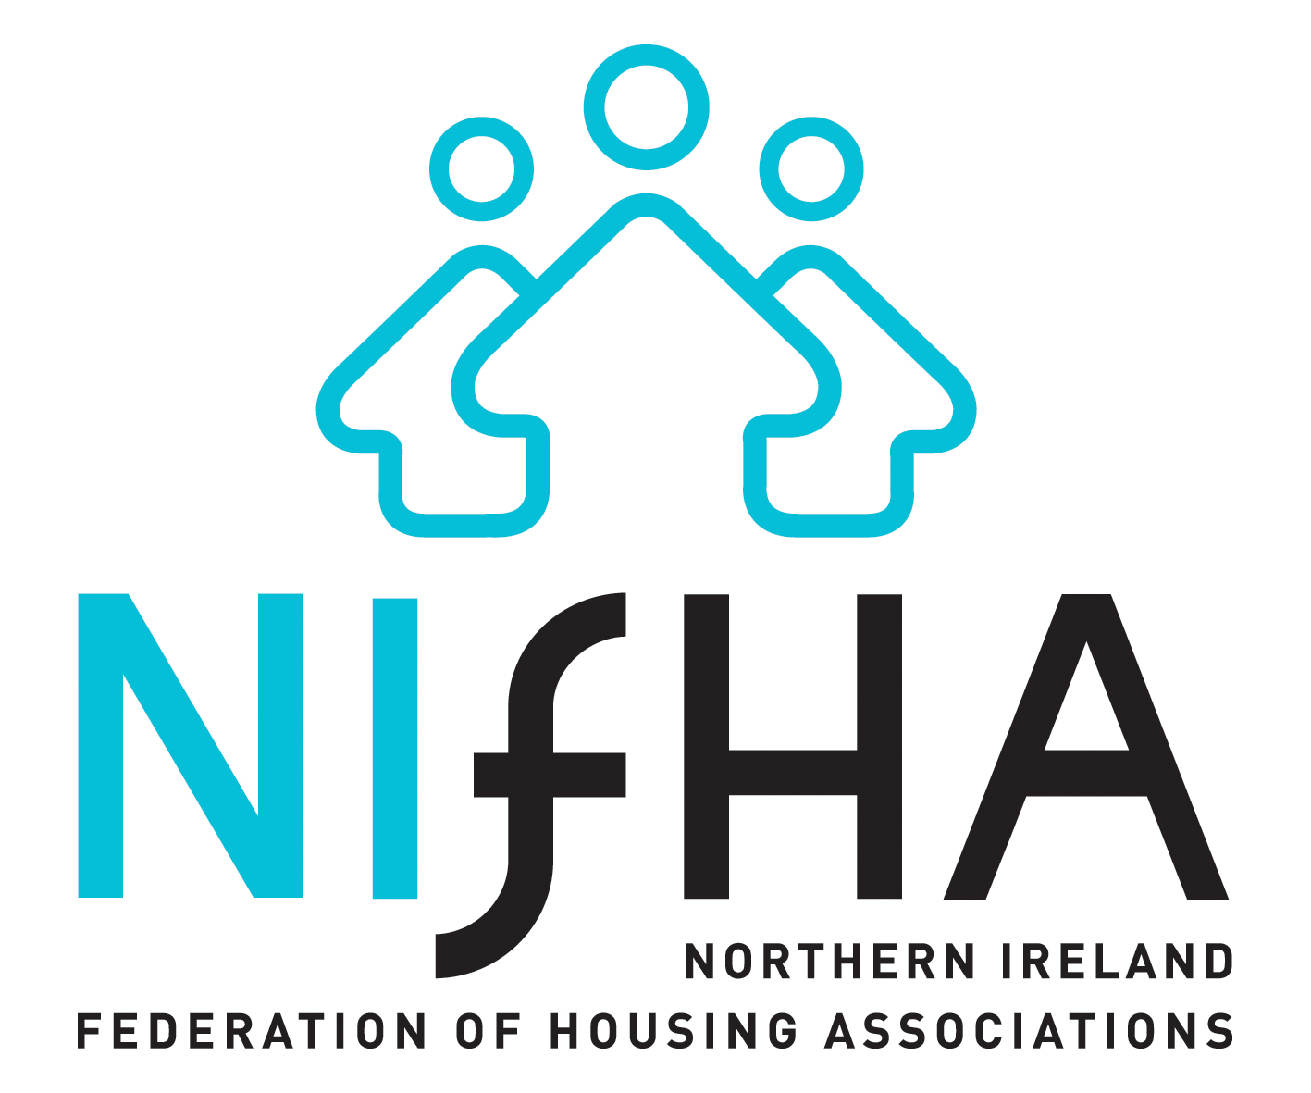 The Northern Ireland Federation of Housing Associations (NIFHA) is the representative body for housing associations in Northern Ireland and supports them in the provision of high quality housing services for the benefit of the community.

Currently, housing associations own and manage 44,000 homes, with a total asset base of over £3bn, employing over 3,000 people. Proposals, from DSD, could see the effective dismantling of the NIHE, with housing associations taking over the ownership of the NIHEs 90,000 properties, which would make housing associations the key player in the provision of social housing in Northern Ireland.

* Providing rented accommodation;
* Specialising in accommodation for special needs groups; and
* Developing new social housing for rent in Northern Ireland

Whilst the term ‘supply chain partnerships’ is the technically correct description for the provision and management of contract services in the social housing market sector, in reality it is primarily those partnerships are concerned with procurement. The procurement of public contracts in Northern Ireland is governed primarily by European Union Regulations and Directives, but also by local Public Procurement Policy, and managed by the Central Procurement Directorate (CPD) of the Department of Finance and Personnel (DFP).

In terms of procurement policy for social housing providers NIFHA believes that both the Department of Social Development (DSD) and the Northern Ireland Housing Executive (NIHE) curtail the ability of housing associations to procure innovatively. In terms of capital spending DSD funds 50% of new-build social housing in NI, with the Housing Associations providing the other 50%, and the inclusion of social clauses in these contracts requires government to ensure that they maximise the social value of that spend. In terms of revenue spend, however, the procurement processes limit the capacity of VCSEs to respond imaginatively or deliver flexibly, being over-reliant on measures of financial, rather than social, value.

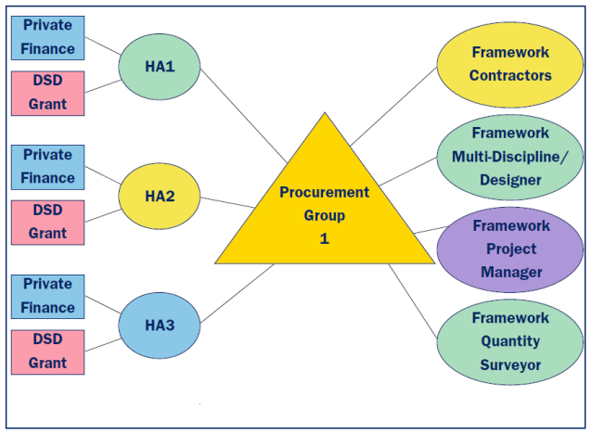

In 2004, the status of Housing Associations changed and it is now accepted that they are Contracting Authorities and are required to comply with European Commission procurement regulations. Housing associations are now subject to aggregation, which places additional restrictions on their ability to sub-contract out work or to work in collaboration with other Housing Associations in the procurement of shared services.

Figure 1 DSD Prefered Procurement Model (2008)

These increasing levels of regulation have removed any sense of flexibility from the procurement system and have created a lack of clarity whilst at the same time unnecessarily extending the length of the procurement process.

DSD now wants Housing Associations to play a regenerative role in local communities which will require them to deliver much more than the basic level of services that they currently provide. This should present an opportunity for Housing Associations to take innovative steps, but it will only be a success if a degree of flexibility is introduced within the process. DSD must recognise that not every intervention will be a success as there is an element of risk involved in “thinking outside the box” in developing new ways to support local community regeneration.

There is also a strong evidence base which highlights that ‘forced collaborations’ do not serve the best interest of the public. A procurement process that is based on shared priorities, is value driven and is outcomes focused, will ultimately address the needs of the public. Forced partnerships, imposed upon organisations, rarely achieve their goals and are often counterproductive. In 2004, DSD reduced the number of procurement groups for Housing Associations from four to three, which created a lack of clarity and reduced the quality of outcomes, which highlighted the need for a more flexible approach from the Department.

There is also a very real need for DSD to judge Housing Associations on more than whether they deliver value for money. Instead of cost being the only determining factor in decisions NIFHA believes that equal weighting must be given to maximising social benefit. Through the enhanced use of social clauses there is potential for Housing Associations to have a wider impact on society which goes beyond delivering a service for the lowest possible cost. If cost, quality and social value are all taken into account, Housing Associations will be able to provide a service that delivers not only for their tenants but also for the wider community, which, in turn, will deliver increased value for money.

NIFHA also believes that sub-economic tendering is a huge risk facing the local market. Sub economic tending occurs when, “firms are prepared to submit uneconomic or unsustainable tender prices to survive. Such practices significantly increase the risk of poor contract performance, create difficulties within supply chains and have a damaging effect on the industry[4].” The over-reliance on contracts being awarded on the basis of value for money, has led to the emergence of sub-economic tendering, and an array of problems which arise out of this practice. Very often firms are encouraged to submit bids as low as possible at the outset, and when problems emerge during the process they either reduce the quality of service delivery or attempt to add additional costs, which skews the budgetary and procurement process.

# Setting up and managing a Supply Chain



Bryson FutureSkills was established in 1989 and was contracted by DEL to provide training and employment programmes to school leavers and the long term unemployed.

They currently employ 87 full and part time members of staff and have an annual turnover of £9.4m in 11 locations in Belfast, Newtownabbey and Foyle.

The Department of Employment and Learning (DEL) is the government department responsible for providing training and employment programmes to young school leavers and the long term unemployed. Their flagship training and employment programmes have undergone a number of changes in recent years, but the three most recent incarnations have been The New Deal[5] (1998-2008), Steps to Work[6] (2008-2014) and Steps 2 Success[7] (2014 - onwards).

The New Deal programme operated across 26 contract areas (based on the 26 council model) and engaged with 147 service providers. In practice, the system was unwieldy and impossible to manage effectively. When the Steps to Work programme commenced in 2008 the number of contract areas was reduced to ten, much larger contracts, with an associated reduction in the number of supply chain partners, from 147 to 48.

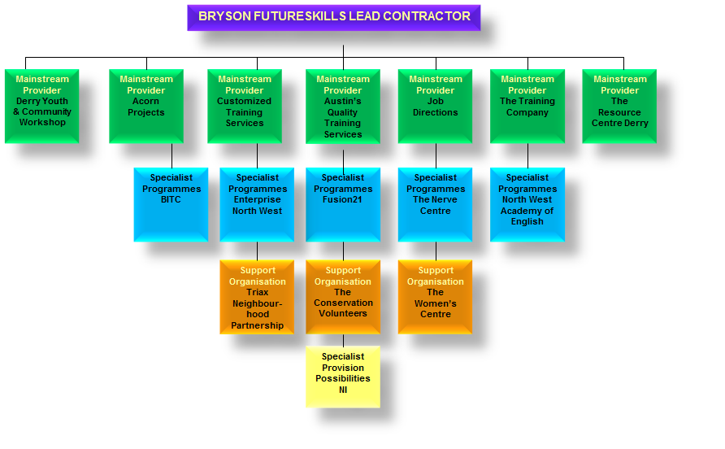Bryson FutureSkills were the lead contractor in three of the contract areas (North Belfast and Newtownabbey from 2008; South and East Belfast from 2011 and Foyle from 2012). Of the 48 supply chain partners Bryson engaged with 13 organisations were from the private sector (27%), 33 were community, voluntary or social enterprises (69%) and two were non-departmental funded bodies (4%).

The 48 supply chain partners provided a wide range of services- 16 of these delivery partners were mainstream providers, 12 were specialist sub-contractors, 10 were support organisations and 10 provided specialist programmes.

Whilst Bryson FutureSkills directly employed 87 full and part time members of staff, with an annual turnover of £9.4m, their 48 supply chain providers created an additional 148 jobs with a combined turnover of £8.07m. These supply chain providers all secured their contracts through the public procurement process and all were awarded their contracts on merit. They all had to demonstrate that they have the relevant experience, have a proven track record of delivery and ability to deliverer the contracted service.

As with all public procurement contracts there was a heavy focus on the programmes being able to deliver value for money and DEL, through their ten lead contractors, engaged in a thorough contract management and quality and compliance process, which involve regular lead contractor/ sub-contractor meetings, review performances, liaison meetings and case conferences, as well as information sessions and support meetings. The entire process was then externally assessed by the Education and Training Inspectorate (ETI) who conducted on-site inspections, client and employer interviews, benchmarking exercises, and followed up with a formal report detailing the strengths, as well as areas for improvement. A formal response was required from supply chain partners in relation to ETIs specific recommendations.

**Education and Training Inspectorate Report Steps to Work Provision: North Belfast and Newtownabbey Contract Area: November 2010.**

*“Outstanding management of the Contract by the Lead Contractor”*

*“Outstanding compliance and quality assurance systems and processes which are leading to continual improvement and capacity building within the Lead Contractor and across all the Sub Contractors”*

**Education and Training Inspectorate Report Steps to Work Provision: South and East Belfast Contract Area: May 2012.**

*“Well developed quality assurance procedures which are being implemented across the Contract Area, and the commitment to continuous improvement and capacity building by the Lead Contractor and the Sub Contractors”*

In July 2014, despite the success of Steps to Work, and of Bryson FutureSkills as lead contractor in three out of ten contract areas, when the contracts were awarded for the three contract areas in the Steps 2 Success programme, all three lead contracts went to companies based in England.

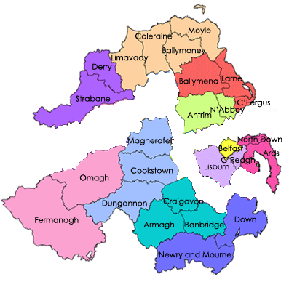

**Belfast Contract Area[8]**

Ingeus UK Ltd, with a proposed end to end Supply Chain of Armstrong (NI),Ingeus UK Ltd, People1st, Springvale Training, supported by a number of specialist local providers.

**Northern Region Contract Area[9]**

EOS Works Ltd, with a proposed end to end Supply Chain of Customized Training Services, Elle Enterprises, EOS, Network Personnel, North City Business Centre, Roe Valley Community Education Forum, Roe Valley Enterprises Ltd, USEL, supported by a number of specialist local providers.

**Southern Region Contract Area[10]**

Reed in Partnership, with a proposed end to end Supply Chain of GLOBAL Education (NI) Ltd (GEL), Network Recruitment (NR), Omagh District Training Consortium (ODTC), Reed in Partnership Ltd, Rutledge Training and Recruitment, South East Regional College (SERC), supported by a number of specialist local providers.

# Reflections from research and policy on supply chains in England

The Third Sector Research Centre is an ESRC-funded research centre at the Universities of Birmingham and Southampton. It is funded through the Cabinet Office and Barrow Cadbury.

In England it is within the employment sector, and to a lesser extent the criminal justice and probation sectors, where supply chains are most entrenched and where there has been the most experience.

When the Northern Ireland experience is compared with that of VCSEs in England, it is clearer that the English system has developed further, but the question as to whether or not this development has been good for the VCSE Sector remains to be answered.

In Northern Ireland, discussions around the use of supply chains and the VCSE Sector are still conducted in terms of ‘partnership’ and ‘collaboration’, which developed during the New Labour years. In Great Britain, since the election of the coalition government in 2010, the debate now centres on the notion of ‘payment by results’, which is influenced by the need for cost savings and deficit reduction. This was driven by the 2007 Department of Work and Pensions (DWP) report ‘Reducing dependency, increasing opportunity’, conducted by Lord Freud.

The report made policy recommendations as to how the Government could continue to reduce economic inactivity and address in-work poverty, and meet the Government’s 80% employment aspiration. Some of its key findings centred on the use of much larger contracts and brought about a much more commercial, private sector approach to service delivery. This approach envisaged a greater role for the private sector, through increased competition, in the award of public sector contracts, which it was felt would reduce the risk to government at a time when resources were scarce. Larger government contracts (the prime contract) were often awarded to a large, private sector organisation, and VCSEs were usually only able to compete for the smaller, specialised contracts.

Since 2010, TSRC suggested that VCSEs often submitted bids which were poorly scored because they focused more “on promise and aspirations” rather than demonstrating ability or providing proof of a strong track record. In the employment sector, the change away from the New Deal scheme, which was seen as being very generous to VCSEs, to projects which place a greater focus on commercial, competitive principles and an emphasis on profit by results, has caught out many within the VCSE Sector.

As VCSEs are motivated by their mission, rather than by profit, the reduced financial support available from grant aid requires that they adapt and learn from organisations within the sector which have had success in adapting to this change. The implementation of the prime/ lead contractor model has increasingly seen the VCSE Sector have to develop stronger links with the private sector. There is overwhelming evidence from the English experience which shows that the payment by results/ outcomes based contracting model often focus solely on value for money, totally neglecting the social benefits and goals.

TSRC recommend that VCSESOs will need to ensure that they go into any supply chain process with their eyes open and apply a degree of organisational savvy. Many private sector prime contractors are engaged in public procurement contracts with the intention of maximising profits which some would argue occurs at the expense of service delivery or the wellbeing of their sub-contractors and VCSESOs. There has also been evidence that prime contractors have effectively used VCSESOs as ‘bid candy’, with the promise of easy money, but in reality the VCSESOs do not receive the referrals that they anticipated and this has a serious impact on the viability of their contract.

Many VCSESOs who have acted as sub-contractors have discovered that they have entered into long term contracts, which cannot be broken, and that they do not receive the expected levels of referrals from other agents within the supply chain. As a result they do not receive the payments they expected and budgeted for when submitting their bids. Many prime contractors, in an attempt to maximise profits, can also make life very difficult for their sub-contractors, with some VCSESOs finding it difficult to secure payment for work carried out.

In order for VCSESOs to succeed at all stages of the supply chain, and for the VCSE Sector to be able to supply services for the benefit of their clients, TSRC make a series of recommendations.

1. VCSESOs need to carry honest assessments of the opportunity and what the exact nature of the offer is and what the 'rules of the game’ are.
2. In the area of commercial skills, where VSCESOs are seen as traditionally being weak, they need to ensure that they increase their focus on building up a knowledge base.
3. VCSESOs need to demonstrate their value in robust manner and they need strong evidence of achieving their principal outcome (and relate this to contracted outcomes)
4. VCSESOs need to further develop their negotiation skills and be willing to say no to offers which could cause them financial hardship in the medium to long term.

# Key messages



The VCSE Sector in Northern Ireland is comprised of 3,821 organisations; of which 3,348 (88%) are Community & Voluntary groups and 473 (12%) are social enterprises. Collectively, the 3,821 Community & Voluntary organisations employ just under 30,000 people, equivalent to around 4% of Northern Ireland’s employees in employment. The estimated total turnover accruing from these VCSE sector organisations was £1.2bn, which is equivalent to around 2% of the total turnover of the region’s business sector.

One of the key outcomes of Phase Two of CollaborationNI is that a report from each policy symposium captures the key messages from the event.

The key messages for the VCSE Sector, for government departments and for politicians are as follows.

## For the VCSE Sector

With an increasing number of payment by results contracts being awarded in Northern Ireland it is important that local VCSESOs are able to learn from the experience of British VCSESOs who have been successful, and unsuccessful, in this process.

Within the VCSE Sector there may increasingly be a role for business mentoring to ensure that VCSESOs are able to compete for contracts with private sector organisations, whilst at the same time retaining and promoting the values and ideals of the VCSE Sector.

In some cases it may be in the interest of VCSESOs to develop stronger linkages to the Private Sector, to consider collaborative work opportunities.

The current 26 local council model will change to an 11 council model on 1st April 2015. These new, ‘super councils’ will each be responsible for their own individual procurement so it is important that VCSEs use the current shadow period, before next April, to develop relationships with these new procurement teams and be ready to take part in the local government procurement process (estimated at over £300m annually[11]).

## For Government Departments

The weighting of the value of social clauses within the commissioning process has to be reviewed to account and to ensure that outcome based funding focuses on delivering better outcomes for communities. There was a clear message on the need for government departments to take into account the added value that local VCSESOs can bring to public contracts through local knowledge, which can be diminished my prime contractors.

The Central Procurement Directorate (CPD) need to examine how they interpret EU legislation to ensure that it does not restrict the ability of VCSESOs to engage in the public procurement process.

## For Politicians

Government policies and processes currently give ‘due regard’ to social value and although this is the right path the only way to fulfil stronger partnerships and roles of VCSE’s potential is if we are able to effectively translate these principles into practice.

We need leadership at the top of to change this. To deliver different outcomes, something different must happen. Strong political will is required to boost the maximisation of social value through commissioning and public procurement

Supply Chains offer VSCESOs an opportunity to work in partnership across the Public and Private Sectors however, in order to encourage VCSE involvement, it is important that VCSESOs are treated as equitable partners within a supply chain.

1. Programme for Government 2011-15, NI Executive (2011), pg. 23
2. Programme for Government 2011-15, NI Executive (2011), pg. 8
3. Economic Strategy: Priorities for sustainable growth and development, NI Executive (2011), pg. 11
4. DFP, *Construction Procurement: Abnormally Low Tenders,* p. 1
5. http://www.delni.gov.uk/index/statsandresearch/training-and-employment-stats/new-deal-statistics.htm
6. http://www.delni.gov.uk/stepstowork
7. http://www.delni.gov.uk/steps2success
8. http://www.delni.gov.uk/index/finding-employment-finding-staff/fe-fs-help-to-find-employment/steps2success.htm
9. Idib
10. Idib
11. http://archive.niassembly.gov.uk/finance/2007mandate/reports/Report_19_08_09R.htm